1. 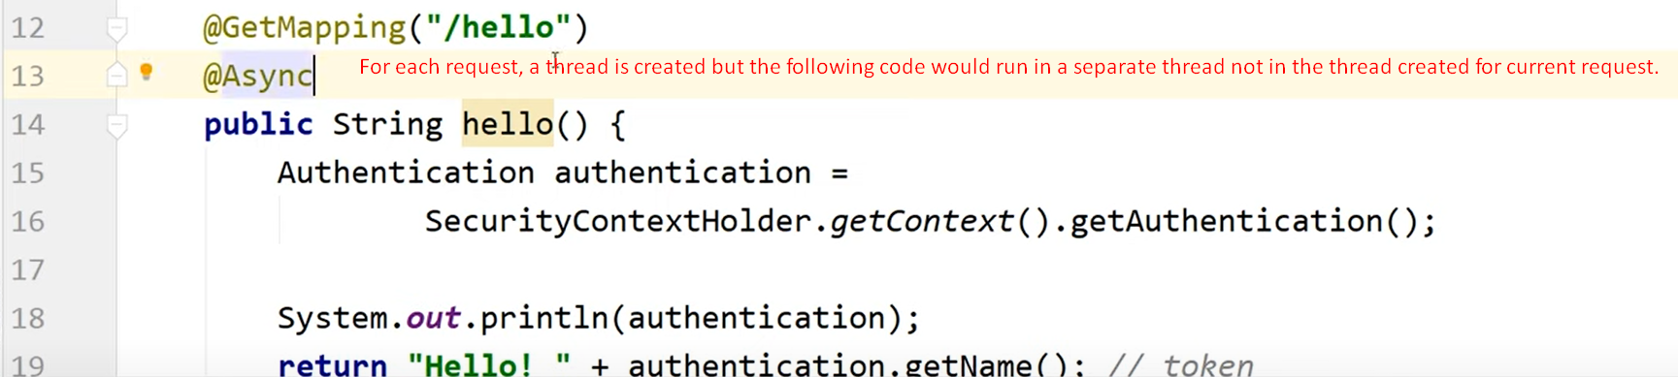 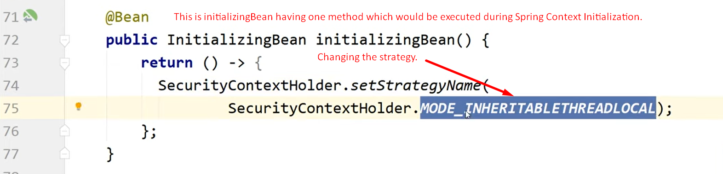
2. 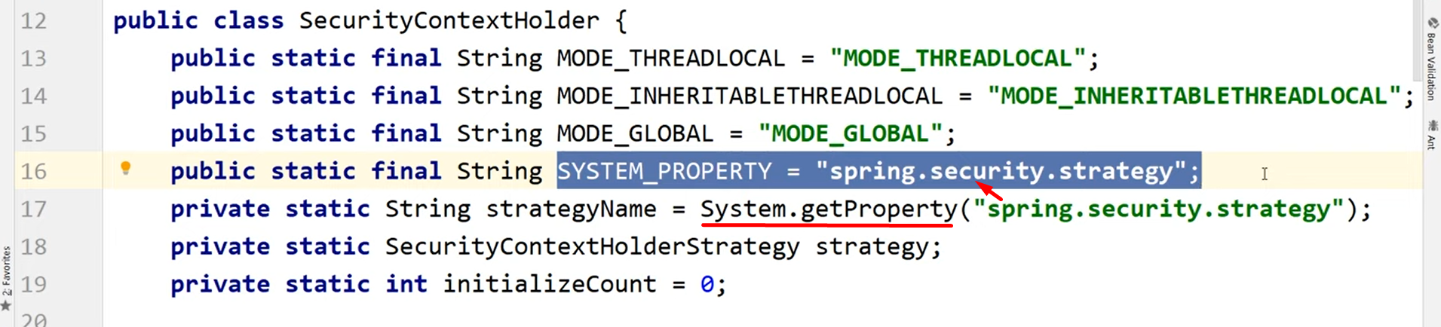
3. 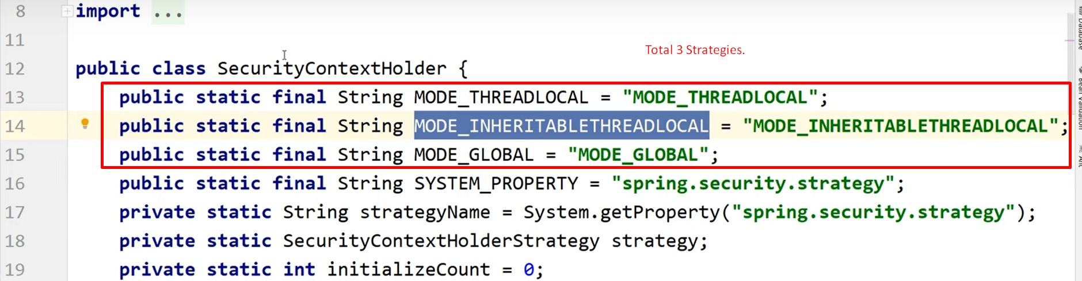
4. **NOTE**: This will work only if Spring is creating thread not when you’re creating a thread.
5. 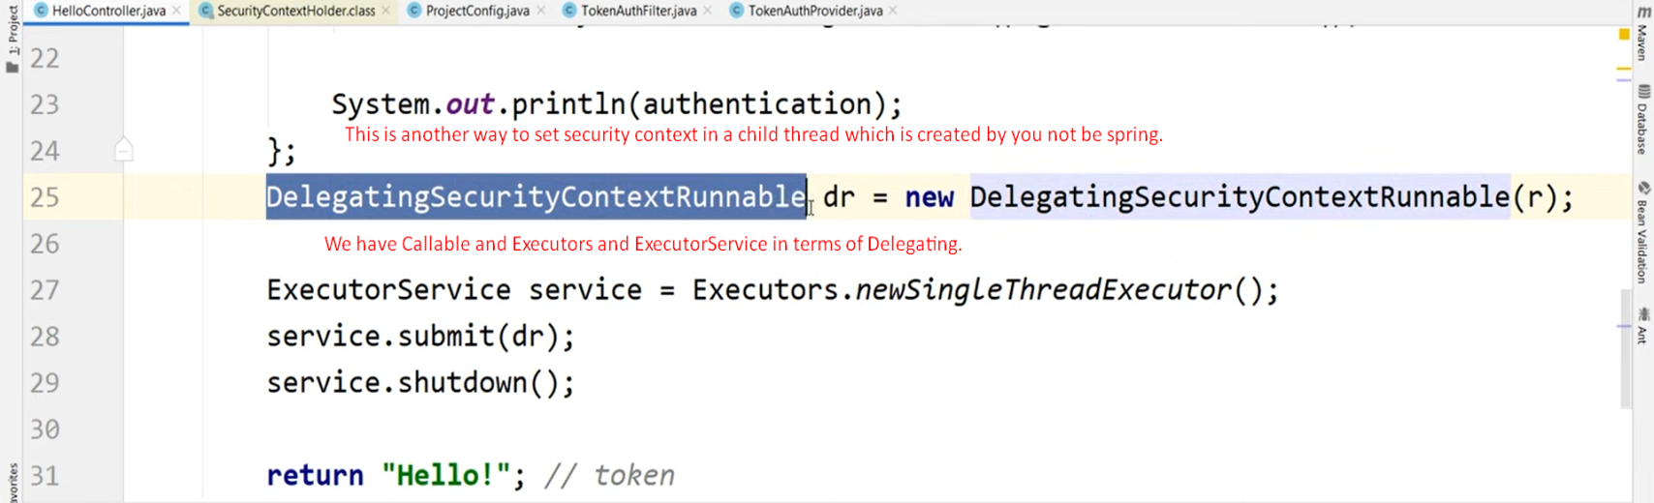
6. 